**Microsoft.com Homepage Layout**

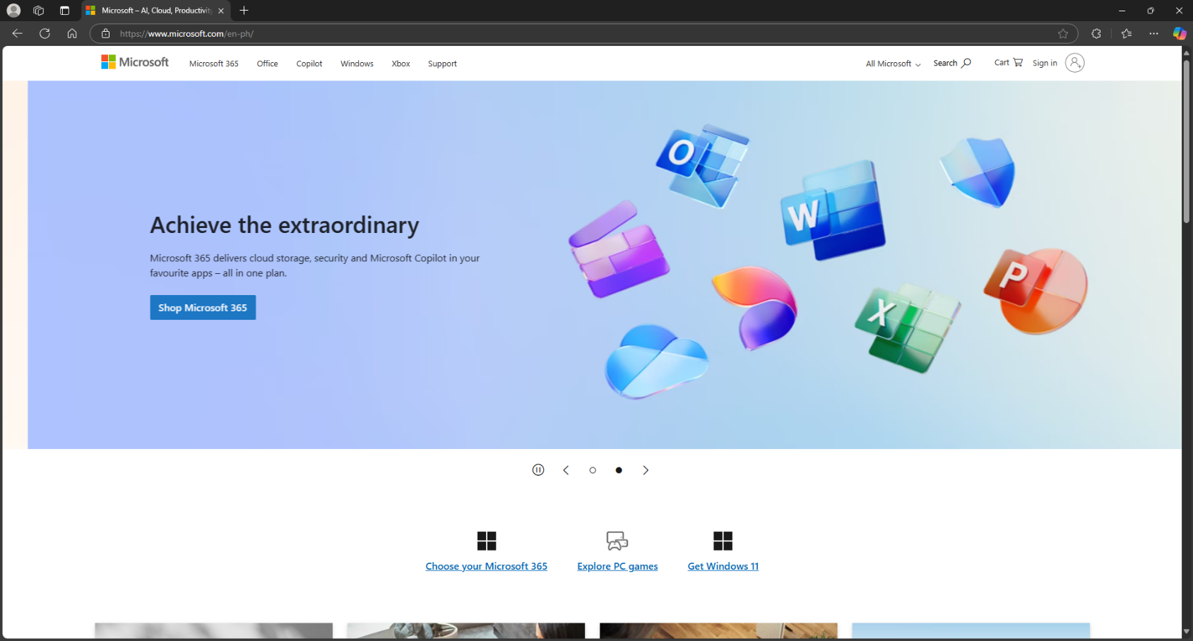Upper section

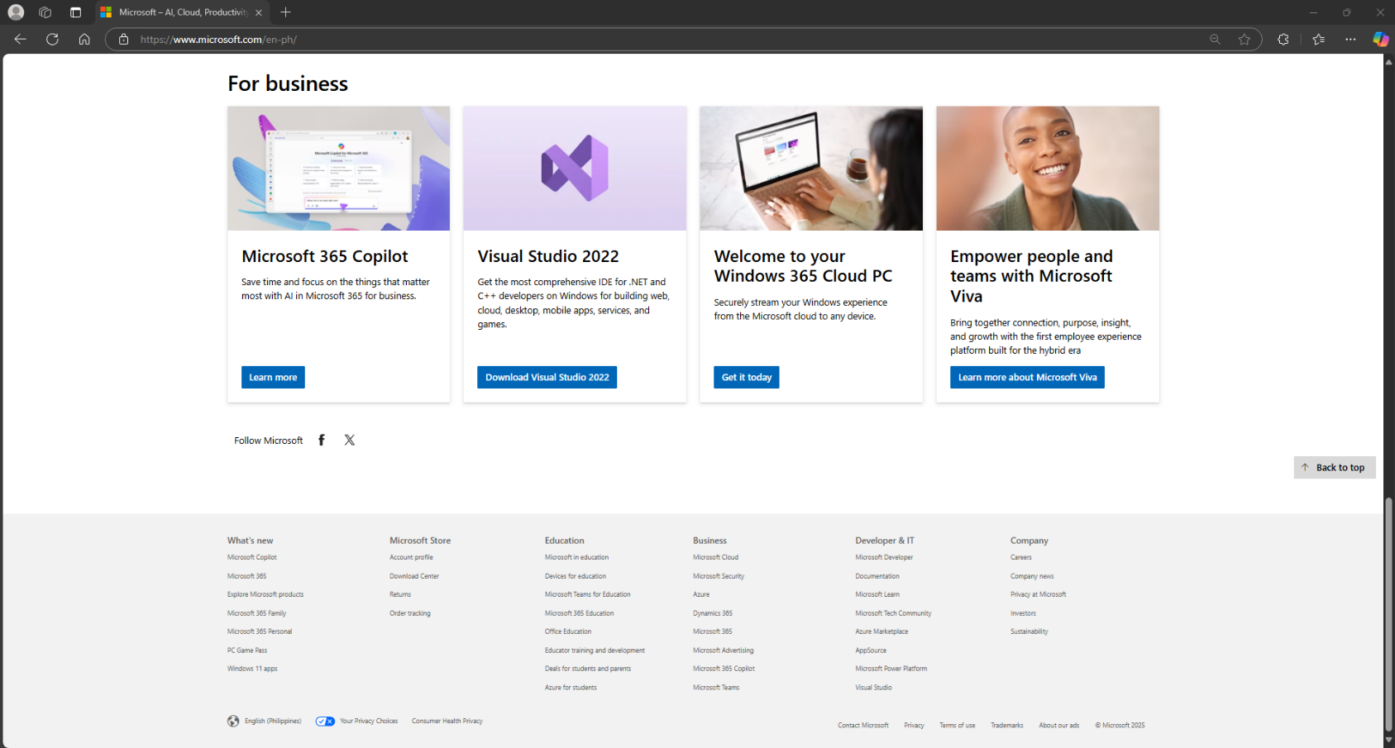Lower section

**Big blocks of Microsoft website:**

* Header – Topmost section
* Navigation bars – upper left section, inside the header
* Main highlight cards – center section
* Main Body content – middle section
* Footer – last section

**Smaller elements:**

* Logo – upper left, inside the header
* Search bar – upper right, inside the header
* Accounts section – beside the search bar and inside the header
* Carousel controls – below the main hightlight cards (upper section)
* Data automation section – middle part, below the carousel controls (upper section)
* Photo containers – inside the main content (lower section)
* Image card, card body, card footer – inside the photo container (lower section)
* Footer nav group – last section, inside the footer area

Sketch of Microsoft Homepage

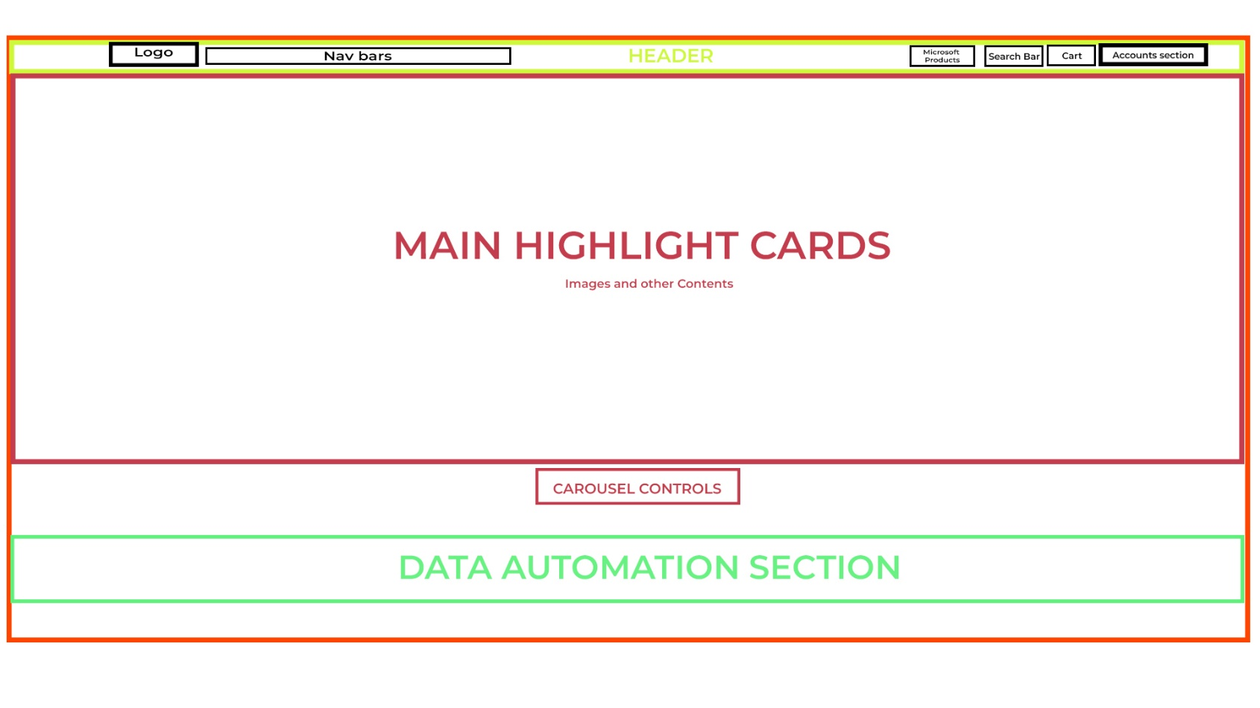Upper section

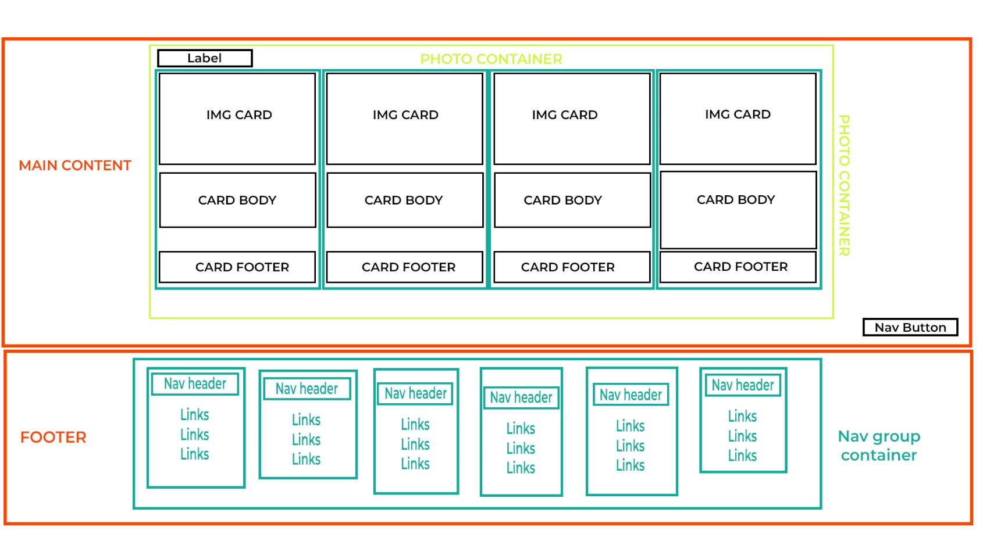Lower section

**Analysis**

I have broken down the sections of the website’s homepage to better understand the hierarchy and structure of each part. First, I identified the key components, including the header, main content area, and footer. I scanned their positioning and the containers used to organize the layout. Additionally, I analyzed smaller but essential elements within the homepage, such as the logo, navigation bar, search bar, and account section, all of which are placed inside the header.

Below the header, the main content section features a carousel that controls the highlighted content, followed by a data automation section that redirects users to more in-depth information about Windows 11. Further down, a photo container displays various Microsoft products and services, consisting of image cards, card bodies, and card footers. The footer section includes a navigation group with a nav header and multiple navigation links. Breaking down the homepage layout helped me visualize its structure and understand how it was designed and developed.

Here's my Github Repository Link: https://github.com/ErbinJames/CSS